GRADE 9 2026 MATHEMATICS APRIL HOMEWORK

ANSWERS

SECTION A (20 Marks)
1. Write 6,923,478 in words
- Number: 6,923,478
- Step 1: Split into millions, thousands, hundreds
  - 6,000,000 → Six million
  - 923,000 → Nine hundred twenty-three thousand
  - 478 → Four hundred seventy-eight
- Combine: Six million nine hundred twenty-three thousand four hundred seventy-eight
Answer: B
2. Simplify: 2x + 2y – 4x + 4y
- Step 1: Group like terms
  - x terms: 2x – 4x = –2x
  - y terms: 2y + 4y = 6y
- Step 2: Combine: 6y – 2x
Answer: B
3. Angles in triangle: x°, (x+10)°, (2x+10)°; find largest angle
- Step 1: Sum of angles = 180°
  - x + (x+10) + (2x+10) = 180
  - 4x + 20 = 180
  - 4x = 160
  - x = 40°
- Step 2: Find largest angle: 2x + 10 = 2(40) + 10 = 90°
Answer: C
4. Sum of next three prime numbers after 47
- Next primes: 53, 59, 61
- Sum: 53 + 59 + 61 = 173
Answer: D

5. Find g if 957g24 divisible by 11
- Rule of divisibility by 11: Sum of alternate digits difference divisible by 11
  - Odd positions: 9 + 7 + 2 = 18
  - Even positions: 5 + g + 4 = g + 9
  - Difference: 18 – (g + 9) = 9 – g
  - 9 – g divisible by 11 → 9 – g = 0 or 11
  - 9 – g = 0 → g = 9
Answer: A
6. If log₁₀ n = –3, find n
- Step 1: Convert to exponential form:
  - log₁₀ n = –3 → n = 10^–3 = 0.001
Answer: A
7. Express 64 in index form
- Step 1: 64 = 2 × 2 × 2 × 2 × 2 × 2 = 2^6
Answer: C
8. Evaluate 12 × 41 – 1 – 20
- Step 1: Multiply: 12 × 41 = 492
- Step 2: Subtract: 492 – 1 – 20 = 471
Answer: B
9. Solve inequality $\frac{2x – 1}{3}+ \left(\frac{X}{2}\right)>2$

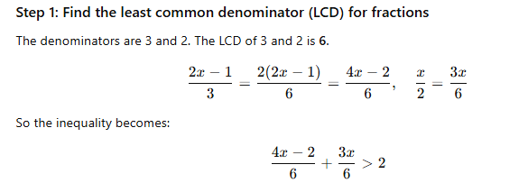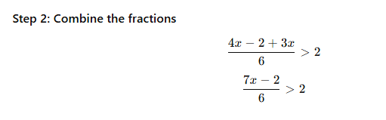
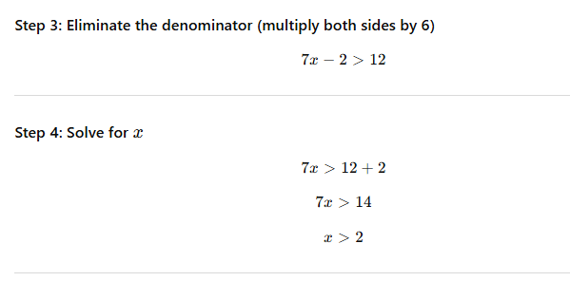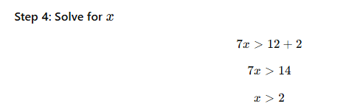

answer: A A

10. Cube side 2.3 m → capacity in litres
- Step 1: Volume of cube: V = s³ = 2.3³ = 12.167 m³
- Step 2: 1 m³ = 1000 L → 12.167 × 1000 = 12,167 L
Answer: D
11. Area of rhombus with diagonals 12 cm and 16 cm
- Formula: Area = (d₁ × d₂) / 2 = (12 × 16)/2 = 192 / 2 = 96 cm²
Answer: C
12. Orodi gave 1/5 land to daughter, 1/3 to son, kept 7 acres. Find total land
- Step 1: Let total land = x acres
- Step 2: Land given away + kept = x
  - 1/5 x + 1/3 x + 7 = x
- Step 3: LCM 5 & 3 = 15 → (3x + 5x + 105)/15 = x → 8x/15 + 7 = x
- Step 4: x – 8x/15 = 7 → 7x/15 = 7 → x = 15
Answer: A
13. Mutua can dig 8 ha in 3 days → work rate/day
- Step 1: Work rate = total work / time = 8 ÷ 3 = 2.67 ha/day
Answer: D
14. Elsie: 7 km in 35 min (5:35 → 6:10)
- Step 1: Time = 6:10 – 5:35 = 35 min = 35 × 60 = 2100 s
- Step 2: Distance = 7 km = 7000 m
- Step 3: Speed = distance / time = 7000 / 2100 ≈ 3.33 m/s
Answer: D
15. Map scale 1:2,000,000 → 3.8 cm
- Actual length = 3.8 × 2,000,000 cm = 7,600,000 cm
- Convert to km: 7,600,000 / 100,000 = 76 km
Answer: B
16. Bulbs flash every 4,6,8,15 s → LCM
- Step 1: Factor each: 4=2²,6=2×3,8=2³,15=3×5
- Step 2: LCM = 2³ × 3 × 5 = 8 × 3 × 5 = 120 s = 2 min
Answer: A

17. Mutiso’s kitchen 3 × 5 m, 260 tiles → area one tile
- Floor area = 3×5 = 15 m²
- Tile area = 15 / 260 ≈ 0.0577 m² → option: 0.0577 ≈ 0.0625
Answer: D

18. D: 140⁰

19. Sum of interior angles of 7-sided polygon
- Formula: (n–2) × 180 = (7–2) × 180 = 5 × 180 = 900°
Answer: A
20. Median of marks: 7,10,5,9,3,10,12
- Step 1: Order data: 3,5,7,9,10,10,12
- Step 2: Median = middle value = 9
Answer: C

SECTION B – Worked Solutions
21. Determine largest fraction: 5/6, 9/11, 14/17
- Convert to decimals:
  - 5/6 ≈ 0.833
  - 9/11 ≈ 0.818
  - 14/17 ≈ 0.823
- Largest = 5/6
Answer: 5/6

22. Price increase ratio 10:9, current price KSh 60
- New price = (10/9) × 60 = 600 / 9 ≈ KSh 66.67
Answer: KSh 66.67

23. Jane bought 150 mangoes KSh 30 each, sold 80 @40, rest @25
- Step 1: Total cost = 150×30 = 4500
- Step 2: Revenue: 80×40 = 3200, remaining 70×25=1750
  - Total revenue = 3200+1750=4950
- Step 3: Profit = 4950–4500=450
- Step 4: Percentage profit = (450/4500) ×100 ≈ 10%
Answer: Profit = 450, % Profit = 10%

24. Number divided by 21 remainder 3, by 28 remainder 3 → smallest number
- Step 1: Number = multiple of LCM(21,28) + 3
- LCM(21,28) = 84 → Smallest number = 84 + 3 = 87
Answer: 87
25. Textile machines problem
- Step 1: Current output: 40 machines × 12 h → 75 tonnes
- Step 2: Output per machine-hour: 75 / (40×12) = 75/480 = 0.15625 t/machine-hour
a) 30 machines × 8 h → 30×8×0.15625 ≈ 37.5 tonnes
b) Produce 100 tonnes in 10h/day → total machine-hours needed = 100 / 0.15625 = 640 h
- Machines needed = 640 / 10 = 64 machines
- Additional machines = 64–40 = 24 machines
Answer: a) 37.5 t, b) 24 machines
26.ANS 113/330
Answer: 171/500
27.Y=4 X=2
- x²=y log_{x}y=2 b)log₁₀0.001=-3
- a)nia –3m+2b=330
2m+5b=550
b)m=50 shillings,b= 90 shillings

- x-7 son now=7+2=9years father now=51years
- a)m=$-\frac{3}{2}$b.$y=-\frac{3}{2x}+\frac{1}{2}$
- 693cm² b) 346cm²
- 25.34
- 15m
- Sh1258
- Sh500000
- Sh 116172.8

a) Construction of Triangle LMN
b) Measure angles of Triangle LMN
i. ∠LMN≈101.5∘
ii. ∠MLN≈45.0∘
iii. ∠LNM≈33.5∘
- C(6,4)
- M=48⁰,T-88⁰ W=80⁰ Th=60⁰ Fr=84⁰

