MARKING SCHEME
- Hundred thousands
- 880808
- 3330, 3303, 3033, 3003
- 4³/₅
- 56, 64
- 810000
- sh. 17850
- Obtuse angle
- 130, 880, 470
- 12
- 11844
- 42
- 70771
- 20000, 24000, 28000, 32000, 36000
- ³/₁₀
- 10
- 5:45/ Quarter to six/45 minutes past five
- 21
- K - 8
W - 2
- 30
- Sh 42 80cts
- 330min
- 16
- ³³/₁₀₀
- 8
- 4100
- 3n + 4f
- 250
- 5m 23cm
- 35

MARKING SCHEME
CREATIVE ARTS
- Line

  - Twining
  - Plaiting
  - Coiling
- Puppetry

  - Old clean socks
  - Glue
  - Buttons
  - Fibre
- Dye
- Puppeteer

  - Camera
  - Mobile phone
  - Tablet
  - Laptop

  - Red
  - Blue
  - Yellow
- Mounting
- Carving
- Hand
- darker

  - Brush
  - Scissors

  - Death of a president in another country
  - Death of current president in a country

  - Drums
  - Bells
  - Shakers
  - Jingles
  - Kayamba

  - Shaking
  - Hitting
  - Plucking
- Choir

  - Patriotic
  - Praise
- Slow

  - Bass
  - Tenor

  - m
  - s
  - t

  - kayamba
  - flute
- Picture of children exchanging a relay button

  - field, long jump
  - A-runway
B - take off board
C - Landing pit
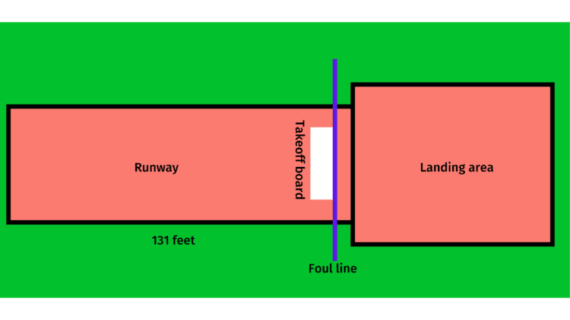
- prevent injury, avoid a tag, make a diversion, because it is the quickest way to the base
- fielders and battlers
- net, ball, posts
- 7
- 4
- 6. Crouch start
- a) flexibility exercise
b) make you flexible

- Run-through finish
- Correct sports attire protects athletes from injuries like cuts and scrapes. It also reduces the risk of serious injury.
- A) bamboo poles
B) Sharpened Sticks For Javelin
C) Rubber To Make Padding
D) Ropes
E) Nets For Table Tennis
- A) rolled newspapers or books
B) Manila
C) adhesive
D) sticks/bamboo
E) Sandpaper
- A) for safety
B) for efficient passing
C) to avoid wasting passing time
- A) it makes something real in a lesson
B) it gives a learner a chance to assess work through self and peer assessment
- A) check the track conditions, for wetness
B) hurdles/flights should be at the correct distance apart
C) hurdles/flights should be the correct height for different age groups
- A) it is a safer way to run
B) we can see what is coming and avoid falling
C) it is a proper running form
- A) sawdust
B) sand.

MARKING SCHEME
ENGLISH
- The Director of Education
- Occupations
- A few local leaders
- Whatever they wanted
- The talk
- Country
Grammar

  - Mine
  - it's
  - his
  - hers
  - ours

  - big, red, traditional
  - tiny, circular, new
  - huge, triangular, brand new
  - big, round
  - large, round, old

  - carpenter
  - Green grocers
  - author
  - pilot
  - veterinary office

  - more beautiful, most beautiful
  - sweet, sweetest
  - old, older
  - fatter, fattest

MARKING SCHEME

SCIENCE AND TECHNOLOGY
- Definite shape

  - Plastic
  - Wood
  - Glass
  - Feathers
  - Cloth
- Opaque

  - Cold
  - Asthma
  - Pneumonia
  - Tuberculosis
  - Covid-19
  - Coughs

  - Algae
  - Moss
  - Fern
  - Pine
  - Cedar
  - Liverworts

  - Source of food
  - Control soil erosion
  - Source of medicine
  - Source of firewood
  - Source of income
  - Beautify environment

  - Typhoid
  - Bilharzia
  - Cholera
  - Dysentery

  - Duck billed platypus
  - Spiny ant eaters
- Cold blooded

  - Body weaknesses
  - Fever
  - headache
  - Vomiting and watery Diarrhea
  - Loss of fluids and severe dehydration
- neck muscles

  - Reuse
  - Recycle
  - Reduce

  - Roundworms
  - Tapeworms
  - Hookworms
  - Pinworms
- H-trachea/windpipe
K-lungs
L-Diaphragm
- Solid,liquid,gas
- The pipe was not straight as light could not travel in a straight line
- Molar tooth
- Sense ofTouch,taste,hearing,smelling,sight

MARKING SCHEME
AGRICULTURE AND NUTRITION
- Garden

  - Safety measure
  - Long lasting

  - Plastic containers
  - Bottles

  - Reduces waste
  - Saves on fertilizer
  - Enhances soil quality and nutrients
- Passion fruits, grapes, blackberries, kiwi fruits, raspberry fruits and gooseberry fruits.

  - It is possible to provide favourable growth conditions
  - Easy weed control
- Soil recovery/restoration
- plants materials, animal waste, food remains or kitchen wastes
- mulching, shading, and cover cropping
- Aphids

Cereals | Vegetables
Rice  Maize  Cowpeas  Beans | Sukuma wiki  Pumpkin

  - Make it soft
  - have good taste
  - Make it easy to digest
  - To last longer
  - Kill germs
  - Make it easy to chew/eat

  - Shape of button
  - Colour of garments
  - Colour of button
- Salty
- laundry

  - Unblocking drainage systems
  - Clearing bushes
  - Proper use of toilets/latrine/urinal
  - Washing hands

  - Increase in weight and height
  - pubic hair grows
  - Pimples appear

  - Eating healthy foods
  - Eating a balanced diet
  - Avoid sugary foods
  - Eat right amount of food

  - One feels uncomfortable
  - Confidence
  - One looks smart
  - people respect a well dressed persoon

  - Radio
  - Television
  - Mobile Device
  - Window display

  - Heart disease
  - Obesity

  - Viruses
  - Fungi
  - bacteria
  - parasites

MARKING SCHEME

SOCIAL STUDIES
- North West
- Christianity
- Tea

  - Farming
  - Fishing
- A resource is something that we use to create wealth.

  - Minerals
  - Soil
  - Water
  - Forests

  - Keeping sources of water clean
  - Using minerals wisely
  - Planting trees
  - Planting cover crops

  - Trade
  - Games and Sports
  - Common language of Kiswahili
  - Free movement of people

  - Relief drainage

    - Fishing e.g lakes
    - Provide water- rivers
    - Tourist attraction- Mountains

    - Avoid dumping litter in lakes and rivers
    - providing security to such areas.

  - Head teacher
  - Deputy head teacher
  - Senior teacher
  - Teachers
  - The children's government
- The number of people living in an area.

  - Story telling
  - Narratives
  - Proverbs
  - Riddles
  - Songs
  - Dances
C.R.E
- John the Baptist
- Jordan
- Dove
- John the Baptist
- Solomon
- Ham
- Belshazzar
- Daniel
- Carmel
- Moses
- Jethro
- He was standing on a Holy Ground

  - Mercy
  - Love
  - Responsibility
  - Empathy
I.R.E

  - It promotes love and friendship among muslims
  - It is a form of due
  - When two people greet one another their sins are forgiven.
  - Allah rewards those who promote greetings.
- 25
- zakat
- Abdullah
- Maakul
- Believing in angels (S.W)
Believing in prophets of Allah (S.W)
- Nabii Adam (AS)
Nabii Muhammad

MWONGOZO WA KUSAHISHA

KISWAHILI
KUSIKILIZA NA KUONGEA
- Anaendesha
- Ni mjamzito
- Anejufungua
LUGHA
Sehemu ya A
- Matapeli
- Mtafute bawabu na askari
- Nyoka
- Wanaodanganya
- Wezi
- Kukupora
Sehemu ya B

  - Bata
  - Nyama
  - Mayai
  - Tamu
  - Gredi
  - Mengi

  - Lakini
  - Kwa sababu
  - Na
  - Kwa sababu

  - Mti wa mapera umekatwa
  - Nguo yake ni chafu sana
  - Kiti kizuri kitauzwa
  - Mkulima analima kwa bidii
  - Embe hilo ni tamu.

  - Kijana
  - Usiku
  - Tajiri
  - Adui
  - Malkia

  - Mlolongo wa magari
  - Safu ya milima
  - Kikosi cha askari
  - jozi la viatu.
  - pakacha la matunda

  - Hali wali mkavu
  - Halali njaa
  - hafi maskini

