KENYA JUNIOR SCHOOL EDUCATION ASSESSMENT (KJSEA)
GRADE 7: SOCIAL STUDIES
CODE: 010 YEAR: 2025 TIME: 1 Hour 40 Minutes
Candidate’s Name: ___________________________________. Assessment Number: _____________________.
School Name: ________________________________________. School Code: _______________________________.

Candidate’s Signature: ______________________________. Date: ________________________________________.
INSTRUCTIONS TO CANDIDATES
- Write the required details in the spaces provided above.
- This paper consists of two sections: A and B.
- Answer ALL questions in Section A and in Section B.
- All answers must be written in the spaces provided.
For official use only
SECTION A: MULTIPLE CHOICE QUESTIONS (20 Marks)
Question No. | 1 | 2 |  | 3 | 4 |  | 5 | 6 | 7 |  | 8 | 9 | 10
Max Score | 1 | 1 |  | 1 | 1 |  | 1 | 1 | 1 |  | 1 | 1 | 1
Candidate’s Score
Question No. | 11 |  | 12 |  |  | 13 |  | 14 |  | 15 |  | 16 | 17 | 18 | 19 | 20 | TOTAL
Max Score | 1 |  | 1 |  |  | 1 |  | 1 |  | 1 |  | 1 | 1 | 1 | 1 | 1 | 20
Candidate’s Score
SECTION B: STRUCTURED QUESTIONS (60 Marks)
Task | Qn Nos. | Max Marks | Candidate's Score
TASK 1: MAPWORK | Q1 a–c | 5
TASK 2: CITIZENSHIP | Q1 a–c | 5
TASK 3: HISTORY | Q1–12 | 30
TASK 4: GEOGRAPHY | Q1–8 | 30
TASK 5: LIFE SKILLS | Q1–3 | 10
TOTAL SCORE (Standardized to 60 Marks) | — | 60
2025 The Kenya Junior School Examination and Assessment Series. Turn over
SECTION A: MULTIPLE CHOICE QUESTIONS (20 Marks)
- Which of the following is NOT a component of Social Studies?
A) Geography
B) Citizenship
C) Physics
D) History
- The Universal Declaration of Human Rights was adopted by the United Nations in:
A) 1945
B) 1948
C) 1963
D) 2010
- Which one of the following is a primary source of historical information?
A) Artifact B) Documentary C) Newspaper D) Textbook
- The main latitude marked 0° is called the:
A) Prime Meridian B) Tropic of Capricorn
C) Equator D) Tropic of Cancer
- The description below is of a certain stone wall that belonged to a certain ancient african kingdom.
- Located in the Masvingo Province.
- The Shona people between the 11th and 15th centuries.
- Served as the royal palace, religious center, and a symbol of political power
The stone wall described above belonged to which Ancient African kingdom?
A) Asante Kingdom
B) Ancient Egyptian kingdom
C) Great Zimbabwe Kingdom
D) Kongo Kingdom
- Which of the following is the correct order of planets from the Sun?
A) Earth, Venus, Mercury
B) Mercury, Venus, Earth
C) Venus, Earth, Mercury
D) Earth, Mercury, Venus


- During an education visit to a certain weather station, Damian saw the following weather instrument.

The weather man explained that the instrument is used to measure atmospheric pressure.
The instrument is called a?
A) Thermometer B) Hygrometer C) Barometer D) Anemometer
- Who among the following was a leader of the Zulu Kingdom in Southern Africa?
A) Shaka Zulu
B) Mansa Musa
C) Menes
D) Samori Toure
- Which one of the following best explains why Europeans colonized Africa?
A) To build schools
B) To spread Christianity only
C) To obtain raw materials and markets
D) To end wars in Africa
- The rule of law in Kenya ensures that:
A) Citizens are punished without trial
B) Leaders are above the law
C) All people are equal before the law
D) The president alone makes laws
- The process of being formally admitted as a citizen of a country is called:
A) Migration
B) Naturalization
C) Emigration
D) Nationalization
- Which early visitor introduced Islam at the East African Coast?
A) British traders
B) Arab traders
C) Portuguese sailors
D) Chinese explorers
- A flight left Nairobi (longitude 37°E) at 10:00 a.m. local time and took 5 hours to reach Lagos (longitude 3°E).
What was the local time in Lagos when the plane landed?
A. 1:00 p.m. B. 12:00 noon
C. 2:00 p.m. D. 3:00 p.m.
- A person who collects, studies, and preserves historical remains is called a:
A) Geographer
B) Archaeologist
C) Historian
D) Anthropologist
- Which of the following is NOT a characteristic of human rights?
A) Universal B) Divisible C) Alienable D) Interdependent
- Which of these was a major effect of the Indian Ocean Slave Trade on East Africa?
A) Rapid industrialization
B) Depopulation of some areas
C) Discovery of new mineral wealth
D) Rise of African nationalism
- The capital city of Ghana is:
A) Lagos B) Accra C) Dakar D) Freetown
- Which of these is an economic use of a forest?
A) Source of rain B) Source of timber
C) Habitat for wild animals D) Provision of oxygen
- The leader who fought against the French colonization in West Africa was:
A) Kwame Nkrumah B) Samori Toure
C) Nelson Mandela D) Dedan Kimathi
- Which of the following promotes unity in diversity in Kenya?
A) Discrimination B) Tribalism C) National festivals D) Segregation
SECTION B: STRUCTURED QUESTIONS (60 Marks)
TASK 1: MAPWORK (5 Marks)
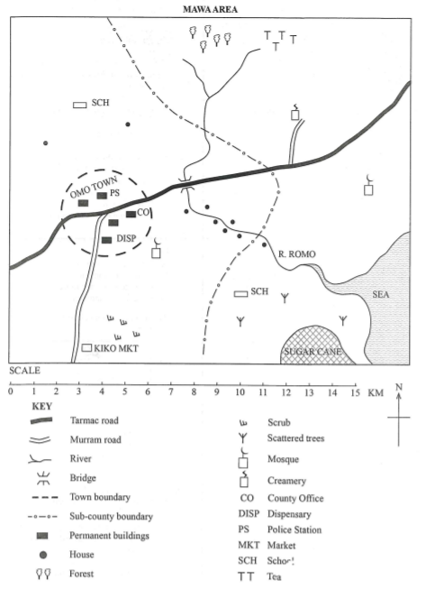
- Study the sketch map of Mawa area below and answer the questions that follow.

a) State two map elements that help in interpreting this sketch. (2 Marks)
i) _________________________________________________________________
ii) ________________________________________________________________
b) In which direction is the school from the creamery? (1 Mark)
_____________________________________________________________________________________________________
c) Differentiate between a Atlas map and a topographical map. (2 Marks)
__________________________________________________________________________________________________________
_________________________________________________________________________________________________________
__________________________________________________________________________________________________________
TASK 2: CITIZENSHIP (5 Marks)
- Your school is planning to mark Madaraka Day with a celebration.
a) State two ways learners can show patriotism during this event. (2 Marks)
i) _______________________________________________________________________________________________________
ii) _______________________________________________________________________________________________________
b) Define the term sovereignty. (1 Mark)
____________________________________________________________________________________________________________________________________________________________________________________________________________________
c) Explain two reasons why respecting human rights is important in a school community. (2 Marks)
i) ________________________________________________________________________________________________________
ii) _______________________________________________________________________________________________________
TASK 3: HISTORY (30 Marks)
- a) Identify the following early humans: (3 Marks)
i) The first to make simple stone tools – __________________________
ii) The first to discover fire – __________________________
iii) The first to make clothing from animal skins – __________________________
b) State one way in which fire improved early man’s life. (1 Mark)
________________________________________________________________________________________________________
________________________________________________________________________________________________________
- a) Use the map of Africa below to answer question
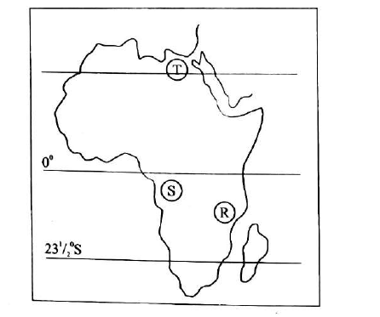
Identify the kingdoms that existed at the places marked (3 Marks)
R: ____________________________________________________
S:____________________________________________________
T:____________________________________________________
b) State two contributions of the Kongo Kingdom to African history. (2 Marks)
i) ________________________________________________________________________________________________________
ii) _______________________________________________________________________________________________________
c) Give one way the Ancient Egyptian Kingdom promoted education. (1 Mark)
________________________________________________________________________________________________________
__________________________________________________________________________________________________________
- a) Name two centers where Arab traders settled along the East African coast. (2 Marks)
i) ______________________________________________________________________________
ii) ______________________________________________________________________________
b) State two cultural influences the Arabs had on the Swahili people. (2 Marks)
i) ______________________________________________________________________________
ii) ______________________________________________________________________________
c) Explain one negative effect of the Indian Ocean Slave Trade. (1 Mark)
________________________________________________________________________________________________________
________________________________________________________________________________________________________
- a) State two ways of preserving historical information in modern times. (2 Marks)
i) ______________________________________________________________________________
ii) ______________________________________________________________________________
b) Give two reasons why oral traditions are important in reconstructing history. (2 Marks)
i) ______________________________________________________________________________
ii) ______________________________________________________________________________
- a) State two causes of the Scramble for Africa. (2 Marks)
i) ______________________________________________________________________________
ii) ______________________________________________________________________________
b) Name the conference that formalized the partition of Africa. (1 Mark)
________________________________________________________________________________________________________
c) State two negative effects of colonial rule on Africans. (2 Marks)
i) ______________________________________________________________________________________________
ii) ______________________________________________________________________________________________
TASK 4: GEOGRAPHY (30 Marks)
- a) Name the capital city of the following country in Africa. (2 Marks)
i) Benin: __________________________
ii) Madagascar:__________________________
b) Identify two economic activities practiced in areas with volcanic soils. (2 Marks)
i) ____________________________________________________________________________________________________.
ii) ___________________________________________________________________________________________________.
c) State two challenges faced by farmers in semi-arid lands. (2 Marks)
i) ___________________________________________________________________________________________________.
ii) __________________________________________________________________________________________________.
- Learners in your school set up a mini weather station.
a) State two features of the Stevenson screen. (2 Marks)
i) ______________________________________________________________________________________________
ii) ______________________________________________________________________________________________
b) Give two uses of rainfall data. (2 Marks)
i) ______________________________________________________________________________________________
ii) ______________________________________________________________________________________________
c) Explain why meteorology is important for farmers. (1 Mark)
____________________________________________________________________________________________________________________________________________________________________________________________________________________
- a) The diagram below shows the internal structure of the earth. (2 Marks)

Name the parts labeled B, C, and D, respectively. (3mks)
B: ______________________________________________________
C: ______________________________________________________
D: ______________________________________________________
b) Give one problem of settlement in highland regions. (1 Mark)
__________________________________________________________________________________________________________
__________________________________________________________________________________________________________
- a) Define the term fieldwork. (1 Mark)
____________________________________________________________________________________________________________________________________________________________________________________________________________________
b) State two advantages of fieldwork in learning Social Studies. (2 Marks)
i) ________________________________________________________________________________
ii) ________________________________________________________________________________
- a) Identify two theories on origin of the solar system. (2 Marks)
i) ________________________________________________________________________________
ii) ________________________________________________________________________________
b) Identify the following weather-measuring instruments. (2 marks)
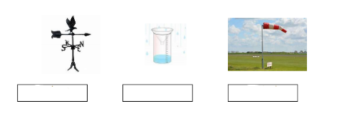
i ) ii)
i) ________________________________________________________________________________
ii) ________________________________________________________________________________
- a) Give one reason why community service learning is important. (1 Mark)
____________________________________________________________________________________________________________________________________________________________________________________________________________________
b) Suggest two examples of community service projects a Grade 7 learner can engage in. (2 Marks)
i) ______________________________________________________________________________________________________
ii) _____________________________________________________________________________________________________
TASK 5: LIFE SKILLS (10 Marks)
- a) State two career opportunities related to Geography. (2 Marks)
i) _______________________________________________________________
ii) ______________________________________________________________
b) Explain one way self-awareness can help in making career choices. (2 Marks)
____________________________________________________________________________________________________________________________________________________________________________________________________________________

- Study the diagram of two learners in a conflict situation.

a) State one step the learners should take to resolve the conflict peacefully. (1 Mark)
____________________________________________________________________________________________________
b) Identify two common causes of conflicts among learners. (2 Marks)
i) __________________________________________________________________________________
ii) __________________________________________________________________________________
c) Give two benefits of peaceful conflict resolution. (2 Marks)
i) __________________________________________________________________________________
ii) __________________________________________________________________________________
- Explain why respecting diversity is important in promoting peace in a school. (1 Mark)
__________________________________________________________________________________________________________
__________________________________________________________________________________________________________

PREPARED BY
COMPETENCE KENYA ASSESSMENT PANEL
0716035408
This Is The Last Printed Page.

