Candidate’s Name: ………………………………………………………… Assessment Number: …………………………………………
School Name: ……………………………………………………………………. School Code: …………………………………………………………
Candidate’s Signature: ………………………………..…………….Date: …………………………………………………….…………….
COMPETENCE BASED EDUCATION
KENYA JUNIOR SCHOOL EDUCATION ASSESSMENT
806/1 AGRICULTURE AND NUTRITION (Theory)
PAPER 1 JUNE 2025 Time: 1 hour 40 minutes
INSTRUCTIONS TO CANDIDATES
- Fill in all the required details above
- This paper consists of two sections: A and B.
- Section A comprises Multiple Choice Questions numbered 1 to 30.
- Section B comprises short, structured questions number 31 to 42.
- Answer ALL the questions in section A on the separate ANSWER SHEET provided.
- Answer ALL the questions in section B in the spaces provided in this QUESTION PAPER.
- Do NOT remove any page from this question paper.
- Answer ALL the questions in English.
For official use only SECTION B
Task | Question | Maximum score | Candidate’s score | Total per task
Task 1: Agriculture | 31 | 3
 | 32 | 3
 | 33 | 3
 | 34 | 3
 | 35 | 4
 | 36 | 4
 | 37 | 4
Task 2: Nutrition | 38 | 2
 | 39 | 2
 | 40 | 5
 | 41 | 2
 | 42 | 5
This paper consists of 9 printed pages. Candidates should check the question paper to ascertain that all the pages are printed as indicated and that no questions are missing. © 2025 The competence based assessment Turn over

SECTION A (30 marks)
Answer ALL the questions in this section.
Please read these instructions carefully
- You have been given this question paper and a separate answer sheet. This section consists of 30 multiple choice questions.
- Answer ALL questions in this section on the ANSWER SHEET provided, NOT on the question paper.
- Do all the necessary rough work on the question paper.
HOW TO USE THE ANSWER SHEET
- Use an ordinary HB pencil.
- Confirm that the answer sheet you have been provided with has the following: YOUR ASSESSMENT NUMBER YOUR NAME NAME OF YOUR SCHOOL NAME OF THE SUBJECT
- Keep the answer sheet clean and dry. DO NOT fold it.
- For each of the questions 1 – 30, four answers are given. The answers are lettered A, B, C and D. In each case, only ONE of the four choices is correct. Choose the correct answer.
- On the answer sheet, the correct answer is to be shown by drawing a DARK LINE inside the box in which the letter you have chosen is written.
Example
In the Question Paper:
- Nairobi City dwellers put garbage at designated areas. The huge amounts of garbage are collected by trucks and deposited at the Dandora dumpsite. This pollutes soil mainly by
A. agricultural chemical wastes. B. artificial fertilizer application. C. plastic wastes. D. waste water.
The correct answer is ‘C’.
On the answer sheet, In the set of boxes numbered 17, draw a DARK LINE inside the box with the letter C printed in it as marked below.
- [A] [B] [C] [D]
- Your dark line MUST be inside the box. DO NOT make any marks outside the boxes.
- For each question, ONLY ONE box is to be marked.

SECTION A (30 marks)
Answer ALL the questions in this section.

- Which of the following soil properties is least affected by poor drainage? A. Soil structure. B. Soil fertility. C. Soil colour. D. Soil texture.
- Which one of the following land preparation methods is most suitable for controlling perennial weeds? A. Minimum tillage. B. Ploughing and harrowing. C. Ripping. D. Subsoiling.
- Compost manure is a valuable organic fertilizer. Which of the following materials is NOT suitable for making compost manure? A. Crop residues. B. Animal manure. C. Polythene papers. D. Kitchen waste.
- A farmer observed wilting in crops despite adequate rainfall. This could be a sign of: A. Excess nutrients in the soil. B. Attack by soil-borne diseases. C. Lack of sunlight. D. Low soil pH.

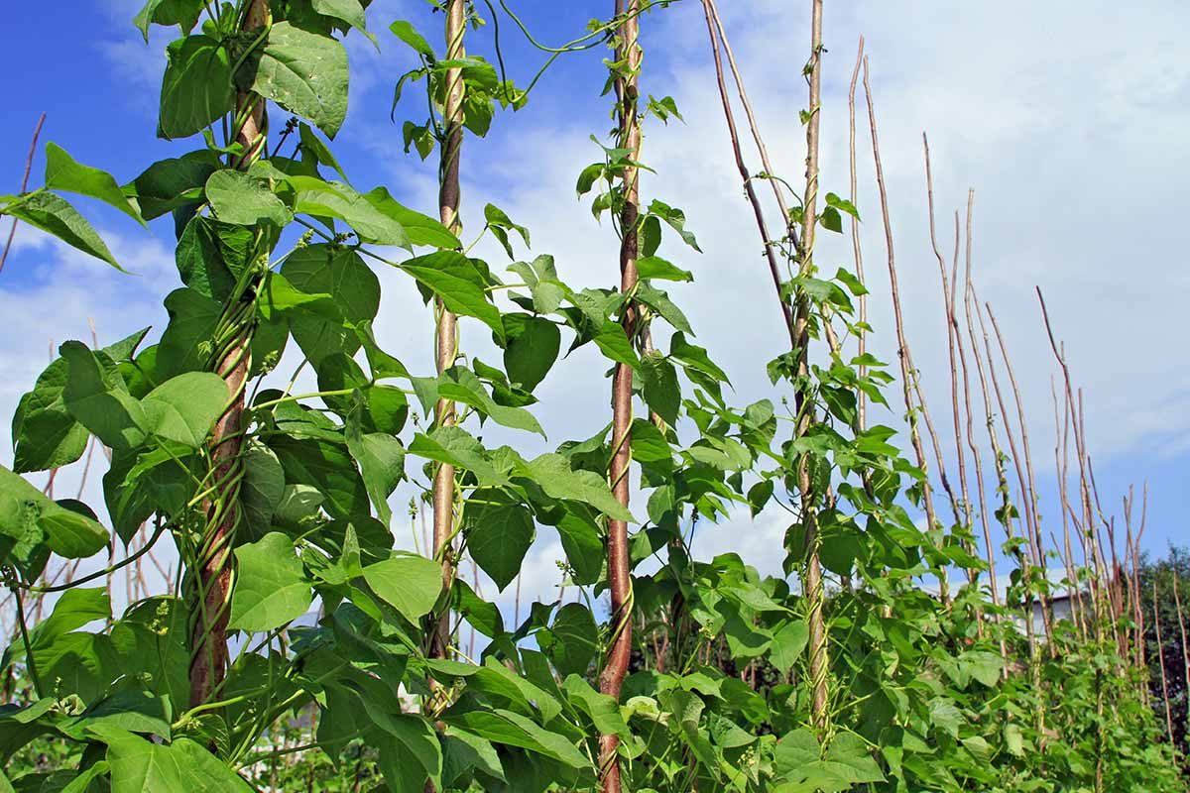
Study the diagram below showing a method of supporting climbing plants. Use it to answer questions 5 and 6.

- Identify the practice shown in the diagram. A. Pruning. B. Mulching. C. Staking. D. Thinning.
- Which of the following crops would most likely benefit from the practice shown? A. Maize. B. Cabbage. C. Tomatoes. D. Wheat.
- Which one of the following is a method of irrigation that minimizes water loss through evaporation? A. Overhead irrigation. B. Furrow irrigation. C. Sprinkler irrigation. D. Drip irrigation.
- Which of the following animal feeds provides the most energy? A. Lucerne. B. Cotton seed cake. C. Maize germ. D. Napier grass.
- Vaccination is an important practice in livestock rearing. What is the main purpose of vaccination? A. To treat sick animals. B. To prevent diseases. C. To control external parasites. D. To improve growth rate.
- A farmer noticed that his dairy cow has swollen udder, redness, and pain during milking. This could be a symptom of: A. Foot and Mouth Disease. B. Mastitis. C. East Coast Fever. D. Bloat.
- Which one of the following practices is NOT a method of controlling external parasites in poultry? A. Dusting the birds. B. Spraying the poultry house. C. Drenching. D. Providing dust baths.
- Which of the following livestock products is a good source of protein and calcium? A. Honey. B. Wool. C. Milk. D. Hides.
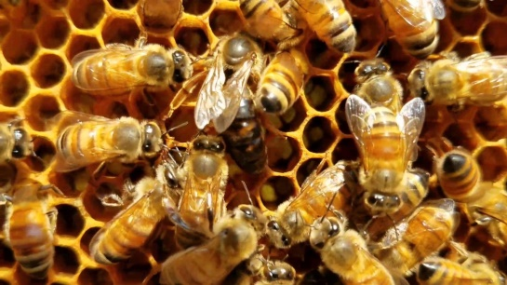
- Naserian was learning about bees. Which type of bee in a colony is responsible for laying eggs?

A. Worker bee. B. Drone. C. Queen bee. D. Soldier bee.
- Farm records are important for decision making. Which record helps a farmer know the profitability of their farm? A. Daily labour record. B. Livestock production record. C. Input record. D. Gross margin record.
- Agribusiness involves the business aspects of agriculture. Which of the following activities is part of agribusiness? A. Planting crops. B. Rearing animals. C. Marketing farm produce. D. Weeding the garden.
- Which of the following nutrients is mainly responsible for growth and repair of body tissues? A. Carbohydrates. B. Fats. C. Proteins. D. Vitamins.
- Rickets is a deficiency disease caused by lack of Vitamin D and Calcium, mainly affecting: A. Eyes. B. Skin. C. Bones. D. Blood.
- Which food group should form the largest portion of a balanced meal? A. Proteins. B. Vitamins and Minerals. C. Carbohydrates. D. Fats and Oils.
- Boiling vegetables for a long time in a lot of water can lead to loss of: A. Starch. B. Fibre. C. Water-soluble vitamins. D. Minerals like calcium.
- What is the main advantage of steaming food? A. It uses less fuel. B. It cooks food quickly. C. It preserves nutrients well. D. It gives food a crispy texture.
- Which one of the following is a method of preserving meat? A. Jam making. B. Smoking. C. Pickling. D. Fermentation.
- Why is it important to cover food while cooking? A. To speed up cooking and conserve heat. B. To prevent food from burning. C. To add flavour to the food. D. To make the food softer.
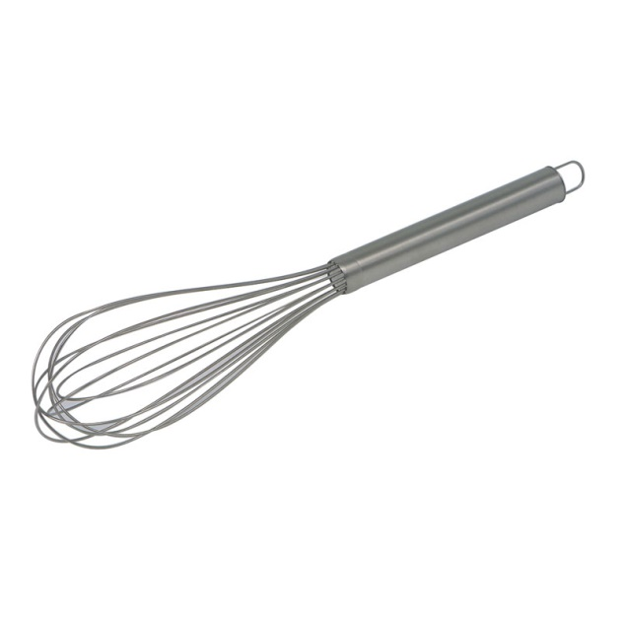
- A menu is a list of dishes to be served. Which of the following factors is least important when planning a menu for a family? A. Nutritional needs of the family members. B. Food preferences of the family. C. Availability of ingredients. D. The price of cooking oil in the market.
- Macharia used the kitchen tool is used for beating eggs or whipping cream. It is called a?

A. Grater. B. Sieve. C. Whisk. D. Colander.
- Which one of the following methods is most effective for removing stubborn dirt and stains from cotton fabrics? A. Soaking in cold water. B. Washing with mild soap and cold water. C. Boiling with strong detergent. D. Kneading and squeezing in lukewarm water.
- What is the main purpose of sorting clothes before washing? A. To make washing faster. B. To prevent colour bleeding and damage to delicate fabrics. C. To use less water. D. To save detergent.
- Which cleaning tool is specifically designed for cleaning narrow spaces and corners? A. Floor brush. B. Dustpan. C. Feather duster. D. Crevice tool (from a vacuum cleaner description context).
- What should be done immediately after using cleaning cloths? A. Leave them to dry in a heap. B. Rinse them and hang to dry. C. Put them back in the storage cupboard. D. Soak them in strong disinfectant overnight.
- Which of the following stitches is used for neatening raw edges of fabric? A. Running stitch. B. Back stitch. C. Hemming stitch. D. Overcasting stitch.
- Which safety precaution should be observed when using sharp sewing tools like needles and scissors? A. Keep them in an open box. B. Pass them to someone else with the points first. C. Store them in a safe, designated container. D. Put them in your mouth when not in use.

SECTION B (40 marks)
Answer ALL the questions in this section.
- Soil structure is important for plant growth. (a) Define the term soil structure. (1 mark)
_______________________________________________________________________
______________________________________________________________________
(b) Give two ways in which good soil structure benefits crops. (2 marks)
________________________________________________________________________
________________________________________________________________________
- Crop diseases can significantly reduce yields. (a) State one symptom of a diseased plant you might observe in the garden. (1 mark)
_________________________________________________________________________
________________________________________________________________________
(b) Outline two methods of controlling crop diseases other than using chemicals. (2 marks)
________________________________________________________________________
________________________________________________________________________
- A farmer is constructing a simple chicken coop for their layers. (a) State one function of a chicken coop. (1 mark)
__________________________________________________________________________
__________________________________________________________________________
(b) Give two essential features that a well-designed chicken coop should have. (2 marks)
________________________________________________________________________
________________________________________________________________________
- Pastoralism is a livestock production system practiced in arid and semi-arid areas.
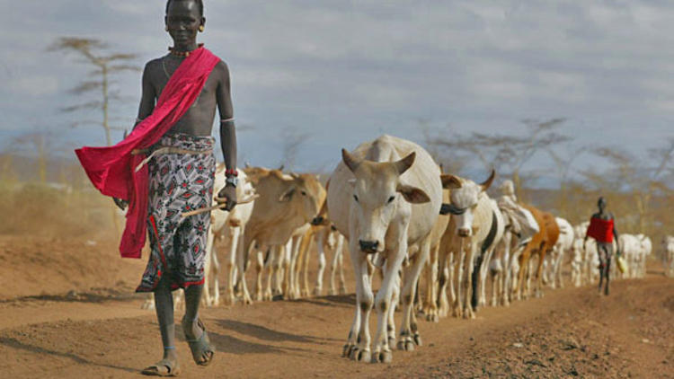
(a) What is pastoralism? (1 mark)
________________________________________________________________________
________________________________________________________________________
(b) Give two challenges faced by pastoralists in Kenya. (2 marks)
________________________________________________________________________
________________________________________________________________________
- Weeds compete with crops for essential resources. (a) Name two types of weeds commonly found in school gardens. (2 marks)

(b) Outline two methods of controlling weeds in a vegetable garden. (2 marks)

- Mwashumbe learnt that Grafting is a method of vegetative propagation. 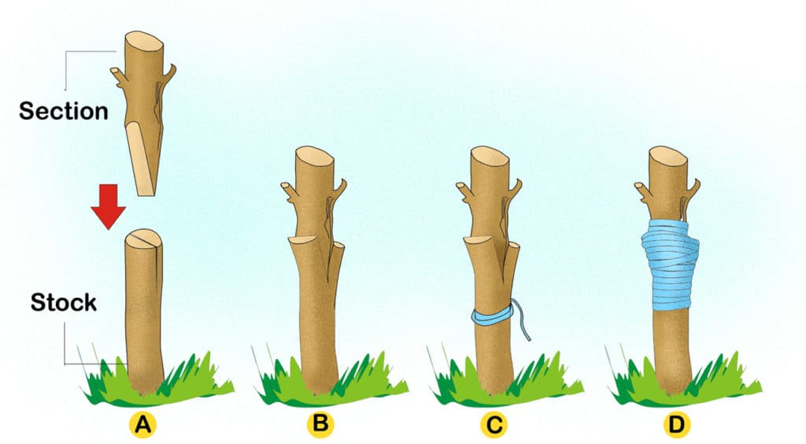 (a) What is grafting? (1 mark)

(b) Give three reasons why farmers practice grafting in fruit trees. (3 marks)

- Organic farming is gaining popularity among farmers. (a) What is organic farming? (1 mark)

(b) Give three advantages of practicing organic farming. (3 marks)

- Explain the importance of eating a variety of foods daily.(2 marks)
__________________________________________________________________________
__________________________________________________________________________
- Outline two disadvantages of frying food. (2 marks)
_________________________________________________________________________
________________________________________________________________________

- During a family get together, Kenyatta prepared a simple fruit salad.

(a) Name two fruits that would be suitable for making a fruit salad. (2 marks)
__________________________________________________________________________
_________________________________________________________________________
(b) Outline three steps involved in preparing a fruit salad. (3 marks)
________________________________________________________________________
________________________________________________________________________
________________________________________________________________________
- State two reasons for disinfecting a sick person's eating utensils separately. (2 marks)
________________________________________________________________________
________________________________________________________________________
- Maintaining a clean and orderly home environment is important. (a) State two benefits of having a clean home environment. (2 marks)
________________________________________________________________________

________________________________________________________________________
(b) Outline three ways in which learners can contribute to keeping their school compound clean. (3 marks)
________________________________________________________________________
________________________________________________________________________
________________________________________________________________________
THIS IS THE LAST PRINTED PAGE.
ANSWERS
SECTION A (30 marks)
- D. Soil texture.
- B. Ploughing and harrowing.
- C. Polythene papers.
- B. Attack by soil-borne diseases.
- C. Staking.
- C. Tomatoes.
- D. Drip irrigation.
- C. Maize germ.
- B. To prevent diseases.
- B. Mastitis.
- C. Drenching.
- C. Milk.
- C. Queen bee.
- D. Gross margin record.
- C. Marketing farm produce.
- C. Proteins.
- C. Bones.
- C. Carbohydrates.
- C. Water-soluble vitamins.
- C. It preserves nutrients well.
- B. Smoking.
- A. To speed up cooking and conserve heat.
- D. The price of cooking oil in the market.
- C. Whisk.
- C. Boiling with strong detergent.
- B. To prevent colour bleeding and damage to delicate fabrics.
- D. Crevice tool
- B. Rinse them and hang to dry.
- D. Overcasting stitch.
- C. Store them in a safe, designated container.
SECTION B (40 marks)
- a) Soil structure refers to the arrangement of soil particles (sand, silt, and clay) into aggregates or peds, separated by pores. b) - Good soil structure allows for better water infiltration and drainage, preventing waterlogging and drought stress.
  - It provides adequate aeration for plant roots to respire and grow.
- a) - Yellowing or browning of leaves. (Other possible answers include spots on leaves, stunted growth, wilting, abnormal growths). b) - Crop rotation: Planting different types of crops in a sequence to break the disease cycle.
  - Using disease-resistant varieties: Planting crops that are less susceptible to common diseases in the area.
- a) A chicken coop provides shelter and protection for the chickens from weather elements, predators, and theft. b) - Adequate ventilation: To ensure fresh air circulation and prevent the build-up of harmful gases and moisture.
  - Protection from predators: Strong walls, a secure roof, and lockable doors to keep out foxes, cats, and other predators.
- a) Pastoralism is a livestock production system where people move with their herds of animals in search of pasture and water, typically in arid and semi-arid regions. b) - Limited availability of pasture and water due to drought and climate change.
  - Conflicts over resources with other communities or due to land use changes.
- a) - Blackjack
  - Pigweed (Other common weeds in your region could also be named). b) - Hand weeding: Physically removing weeds from the garden by pulling them out or using hand tools.
  - Mulching: Covering the soil surface with organic materials (like straw or wood chips) to suppress weed growth.
- a) Grafting is a vegetative propagation method where parts of two different plants are joined together so that they grow as one. The upper part (scion) grows on the root system (rootstock) of the other plant. b) - To combine desirable traits from two different varieties, such as disease resistance from the rootstock and good fruit quality from the scion.
  - To propagate varieties that do not produce viable seeds or are difficult to propagate by other methods.
  - To shorten the time to maturity and fruiting compared to growing from seed.
- a) Organic farming is a system of agriculture that avoids the use of synthetic fertilizers, pesticides, genetically modified organisms (GMOs), and growth regulators. It relies on practices like crop rotation, composting, and biological pest control. b) - Improved soil health and fertility due to the use of organic matter and natural farming practices.
  - Reduced environmental pollution as synthetic chemicals are not used.
  - Production of healthier food that is free from synthetic pesticide residues.
- Eating a variety of foods daily ensures that the body receives all the essential nutrients it needs for proper growth, development, and function. Different foods provide different vitamins, minerals, carbohydrates, proteins, and fats, all of which play vital roles in maintaining good health and preventing nutrient deficiencies.

  - Loss of some nutrients: High heat during frying can destroy certain vitamins and antioxidants in food.
  - Increased fat content: Frying adds extra fat to food, which can contribute to weight gain and related health problems if consumed frequently.
- a) - Bananas
  - Pawpaw (Other suitable fruits include mangoes, pineapples, oranges, watermelon). b) - Wash all the fruits thoroughly under clean running water to remove any dirt or contaminants.
  - Peel and cut the fruits into bite-sized pieces, removing any seeds or cores.
  - Combine the cut fruits in a clean bowl and mix gently. (Optional: Add a squeeze of lemon or lime juice to prevent browning and enhance flavor).

  - To prevent the spread of infection from the sick person to others through shared utensils.
  - To ensure that any germs or pathogens from the sick person are thoroughly removed from their eating utensils.
- a) - Reduced risk of diseases: A clean home environment minimizes the presence of germs, pests, and allergens that can cause illnesses.
  - Improved comfort and well-being: A clean and orderly home is more pleasant to live in and can reduce stress. b) - Participating in cleaning schedules and tasks assigned in school, such as sweeping classrooms or tidying common areas.
  - Properly disposing of litter in designated bins and encouraging others to do the same.
  - Taking care of school property and reporting any damage or spills to teachers or responsible personnel.

