Candidate’s Name: ………………………………………………………… Assessment Number: …………………………………………
School Name: ……………………………………………………………………. School Code: …………………………………………………………
Candidate’s Signature: ………………………………..…………….Date: …………………………………………………….…………….
COMPETENCE BASED EDUCATION
KENYA JUNIOR SCHOOL EDUCATION ASSESSMENT
803: MATHEMATICS
JUNE 2025 Time: 2 hours
INSTRUCTIONS TO CANDIDATES
- Fill in the appropriate information in the spaces provided above.
- This question paper consists of TWO sections: A and B.
- Answer ALL the questions in section A on the separate ANSWER SHEET provided.
- Answer ALL the questions in section B in the spaces provided in this QUESTION PAPER.
- Show all the workings in section B in the spaces provided.
- Non-programmable calculators may be used, except where stated otherwise.
- Give non-exact numerical answers, correct to 3 significant figures, and one decimal place for angles in degrees, unless a different level of accuracy is specified in the question.
- For π, use either the calculator value or 3.142.
- Do NOT remove any page from this question paper.
- Answer ALL the questions in English.
For official use only
Section | Task | Question Numbers | Max. Score | Score
B
 | Task 1 | 21, 22, 23 | 18
 | Task 2 | 24, 25 | 12
 | Task 3 | 26, 27, 28 | 20
 | Task 4 | 29, 30, 31 | 18
 | Task 5 | 32, 33, 34 | 12
 |  | Total

This paper consists of 17 printed pages. Candidates should check the question paper to ascertain that all the pages are printed as indicated and that no questions are missing.

© 2025, The Competence Based Assessment Turn over

SECTION A (20 marks)
Answer all the questions in this section.
- You have been given this question paper and a separate answer sheet. Answer All the questions in Section A on the separate answer sheet provided.
- When you have chosen your answer, mark it on the ANSWER SHEET, not in this question paper.
HOW TO USE THE ANSWER SHEET
- Use an ordinary HB pencil.
- Confirm that the answer sheet you have been provided with has the following:
YOUR ASSESSMENT NUMBER YOUR NAME NAME OF YOUR SCHOOL NAME OF THE SUBJECT
- Keep the answer sheet clean, dry and DO NOT fold it.
- For each of the questions 1 – 20, four answers are given. The answers are lettered A, B, C and D. In each case, only ONE of the four answers is correct. Choose the correct answer.
- On the answer sheet, the correct option is to be shown by drawing a dark line inside the box in which the letter you have chosen is written.
Example:
In the Question Booklet:
  - What is the square root of 196?
A. 12 B. 13 C. 14 D. 16
The correct answer is C.
On the answer sheet, in the set of boxes given for number 10, draw a dark line inside the box with the letter C printed in it as indicated below.
10 [A] [B] [C] [D]

- Your dark line MUST be inside the box.
- For each question, ONLY ONE box is to be marked in each set of four boxes.

SECTION A (20 marks)
Answer all the questions in this section.

- Calculate 120÷4×5. A. 6 B. 15 C. 150 D. 240
- What is the value of (−8)−(−3)? A. -11 B. -5 C. 5 D. 11
- Express 0.075 as a fraction in its simplest form. A. $\frac{75}{1000}$​ B. $\frac{3​}{40}$ C. $\frac{15}{200​}$ D. 5 $\frac{1}{7}$​
- Find the place value of digit 9 in the number 358.149. A. ones B. hundreds C. tenths D. thousandths
- Which one of the following numbers is a prime number? A. 21 B. 29 C. 33 D. 39
- Simplify the expression 7a−2b−3a+5b. A. 4a+3b B. 4a+7b C. 10a+3b D. 10a+7b
- Solve the equation 5m+8=23. A. m=3 B. m=3.6 C. m=5 D. m=31
- Convert 45% to a decimal. A. 45.0 B. 4.5 C. 0.45 D. 0.045

WORKING AREA

- A class has 18 boys and 12 girls. What is the ratio of boys to the total number of learners in simplest form? A. 18:12 B. 3:2 C. 3:5 D. 2:3
- Two angles on a straight line are (x+10)∘ and 70∘. What is the value of x? A. 10 B. 100 C. 110 D. 180
- The interior angle of a regular polygon is 120∘. How many sides does the polygon have? A. 4 B. 5 C. 6 D. 8
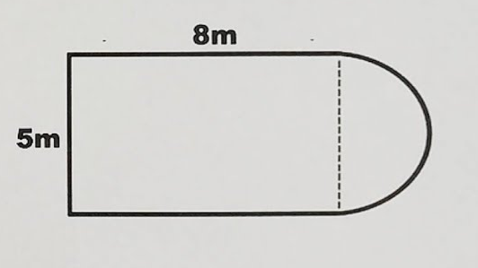
- Calculate the perimeter of the figure below.

- 85.23 cm
- 58.87cm
- 28.86cm
- 2.9cm

WORKING AREA

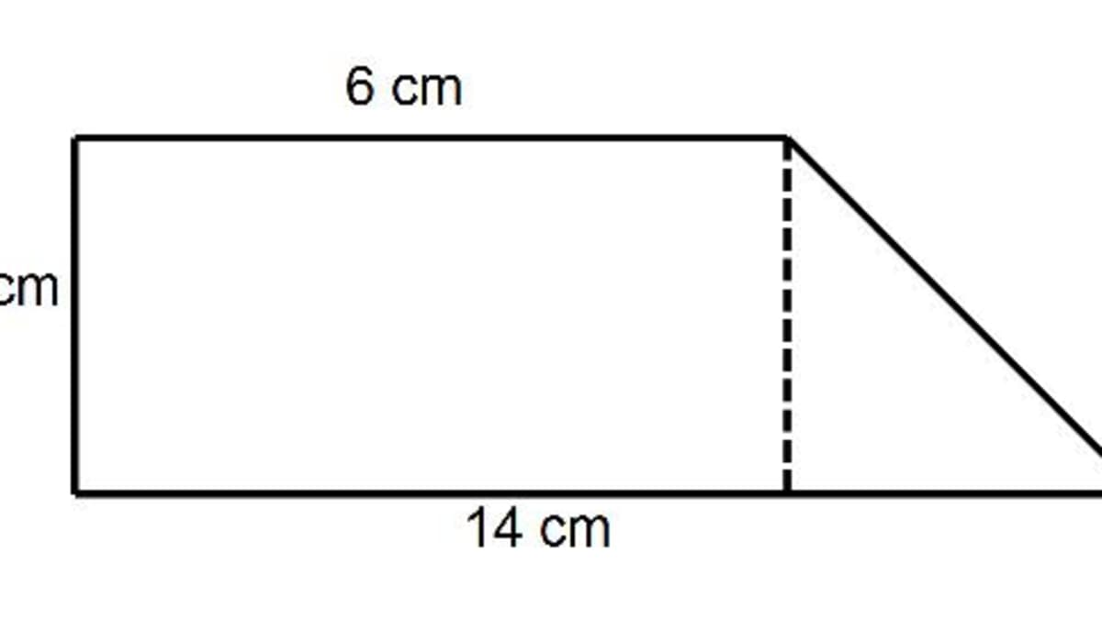
- Find the area of the figure below

5

A. 30 cm² B. 60 cm² C. 40 cm² D. 50 cm²
- Mukami wants to buy a dress that costs Ksh 1800. The shop is offering a 15% discount. How much will Mukami pay for the dress after the discount? A) Ksh 270 B) Ksh 1530 C) Ksh 1785 D) Ksh 2070
- A matatu left Nairobi at 10:00 am and arrived in Nakuru, which is 150 km away, at 12:30 pm. What was the average speed of the matatu in km/h? A) 50 km/h B) 60 km/h C) 75 km/h D) 150 km/h
- A rectangular water tank has a base measuring 3 meters by 2 meters and a height of 1.5 meters. What is the maximum volume of water, in cubic meters, that the tank can hold? A) 6m³ B) 9m³ C) 10.5m³ D) 11.5m³

WORKING SPACE

- The number of learners absent from a class for five days were recorded as follows: 3, 1, 4, 2, 5.
What is the median number of absent learners over these five days? A) 1 B) 2 C) 3 D) 4
- When a number is multiplied by 3 and then 5 is added, the result is 29. If the number is represented by x, which equation represents this situation, and what is the value of x? A) 3x−5=29; x=11.33 B) 3x+5=29; x=8 C) 5x+3=29; x=5.2 D) 5x−3=29; x=6.4
- Kamau had Ksh 2500 in his bank account. He withdrew Ksh 1200 and later deposited Ksh 800. What is his new bank balance? A) Ksh 500 B) Ksh 1300 C) Ksh 2100 D) Ksh 4500
- In a class of 40 learners, 60% are girls. How many boys are in the class? A) 16 B) 20 C) 24 D) 40

WORKING SPACE

SECTION B (80 marks)
Answer all the questions in the spaces provided. Show all your working.
Task 1 (18 Marks)
- A shopkeeper bought 200 kg of sugar at Ksh 150 per kg. He sold 150 kg at Ksh 180 per kg and the remaining amount at Ksh 160 per kg. (a) Calculate the total cost price of the sugar. (2 marks)

(b) Calculate the total amount received from selling the sugar. (3 marks)

(c) Calculate the profit or loss made by the shopkeeper. (2 marks)

- Three boys, Alex, Brian, and Chris, shared Ksh 7200 in the ratio 2:3:4 respectively. (a) Calculate the total number of parts in the ratio. (1 mark)

(b) Calculate the amount of money each boy received.

Alex: ___________ Brian: ___________ Chris: ___________ (3 marks)
- Simplify the following: (a) 5³​ × 8³​ (2 marks)

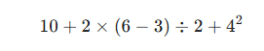
(b) (5 marks)

Task 2 (12 Marks)
- Solve for x in the following equations: (a) 4x−7=x+5 (3 marks)

(b) 2(3x−4)=10 (3 marks)

- Solve the simultaneous equations:
x+y=7
2x−y=5 (6 marks)

Task 3 (20 Marks)
- The diagram below shows a piece of chicken land.
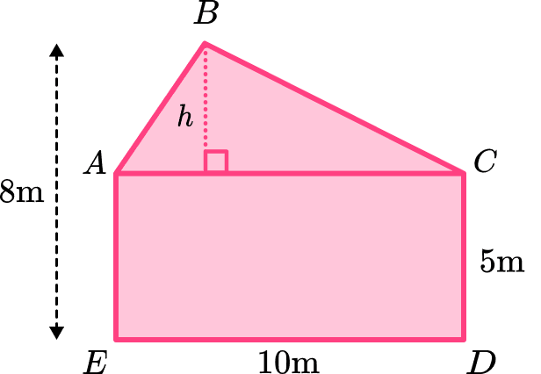

(a) Divide the land into suitable basic shapes. (1 mark)

(b) Calculate the area of each basic shape. (4 marks)

(c) Calculate the total area of the piece of land. (1 mark)

- A cylindrical water tank has a diameter of 4.2 m and a height of 3 m.
(a) Calculate the radius of the tank. (1 mark)

(b) Calculate the area of the base of the tank. (Use π=3.142) (2 marks)

(c) Calculate the volume of the tank in cubic metres. (2 marks)

(d) Calculate the capacity of the tank in litres. (Given that 1 m³=1000 litres) (1 mark)

- A rectangular prism measures 15 cm by 10 cm by 8 cm. (a) Calculate the volume of the prism. (2 marks)

(b) Calculate the total surface area of the prism. (4 marks)

Task 4 (18 Marks)
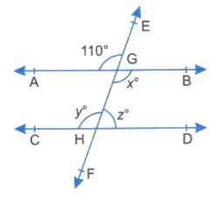
- In the diagram below, AB is parallel to CD. EF is a transversal line.

You are required to Calculate:
(a) Angle EGC (2 marks)

(b) Angle DGH (2 marks)

(c) Angle AGH (2 marks)

- A triangle ABC has vertices A (1, 1), B (5, 1), and C (3, 4).
(a) Plot triangle ABC on the Cartesian plane below. (Provide a grid for plotting) (3 marks)
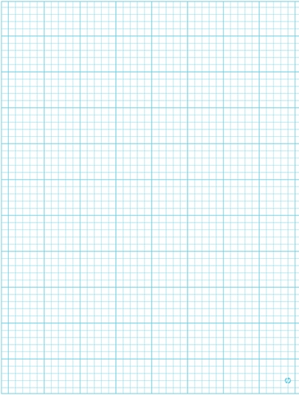

(b) Calculate the length of the base AB. (1 mark)

(c) Determine the height of the triangle from C to the base AB. (1 mark)

(d) Calculate the area of triangle ABC. (2 marks)

- A regular polygon has an exterior angle of 40∘. (a) Calculate the number of sides of the polygon. (2 marks) (b) Calculate the size of each interior angle. (2 marks) (c) Calculate the sum of the interior angles of the polygon. (2 marks)
Task 5 (12 Marks)
- The table below shows the number of different types of trees planted by a school in a week.
Type of Tree | Number of trees
Pine | 40
Cypress | 60
Gravillea | 50
Eucalyptus | 30
  - How many trees were planted in total? (1 mark)

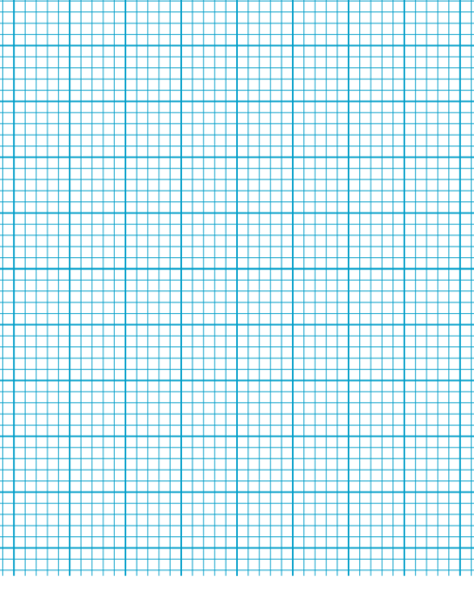
  - Represent the data using a bar graph on the grid provided below. (Provide a grid for drawing the bar graph) (4 marks)

- The following are the scores of 9 learners in a test:

15, 12, 18, 10, 15, 14, 18, 15, 11
(a) Calculate the mean score. (2 marks)

(b) Determine the median score. (2 marks)

(c) Determine the mode score. (1 mark)

- A class collected the following data on the number of pets owned by each learner:
0, 1, 2, 1, 3, 0, 1, 2, 1, 0, 3, 2, 1, 0, 1
(a) Complete the frequency table for this data. (2 marks)
Number of Pets | Tally | Frequency
0
1
2
3
(b) How many learners were surveyed? (1 mark)

THIS IS THE LAST PRINTED PAGE.

Answers
SECTION A (20 marks)
- C
- B
- A
- D
- B
- A
- A
- C
- C
- B
- C
- B
- A
- B
- B
- B
- C
- B
- C
- A
SECTION B (80 marks)
Task 1 (18 Marks)
- (a) Ksh 30000 (b) Ksh 35000 (c) Ksh 5000 (Profit)
- (a) 9 (b) Alex: Ksh 1600, Brian: Ksh 2400, Chris: Ksh 3200
- (a) 12800 (b) $29$
Task 2 (12 Marks)
- (a) (x = 4) (b) (x = 3)
- (x = 4), (y = 3)
Task 3 (20 Marks)
- (a) rectangle and a triangle (b) rectangle: 80 m², triangle: 24 m² (c) 104 m²
- (a) 2.1 m (b) 13.85922 m(^2) (c) 41.57766 m(^3) (d) 41577.66 litres
- (a) 1200 cm(^3) (b) 700 cm(^2)
Task 4 (18 Marks)
- (a) 105° (b) 105° (c) 75°
- (a) (See previous full answer for the plot) (b) 4 units (c) 3 units (d) 6 square units
- (a) 9 sides (b) 140° (c) 1260°
Task 5 (12 Marks)
- (a) 180 trees (b) (See previous full answer for the bar graph)
- (a) 14.2 (to 3 s.f.) (b) 15 (c) 15
- (a)
Number of Pets | Tally | Frequency
0 | //// | 4
1 | //// | 5
2 | /// | 3
3 | // | 2

(b) 14

