Candidate’s Name: ………………………………………………………… Assessment Number: …………………………………………
School Name: ……………………………………………………………………. School Code: …………………………………………………………
Candidate’s Signature: ………………………………..…………….Date: …………………………………………………….…………….
COMPETENCE BASED EDUCATION
KENYA JUNIOR SCHOOL EDUCATION ASSESSMENT
807: SOCIAL STUDIES
JUNE 2025
Time: 1 Hour 30 Minutes
INSTRUCTIONS TO CANDIDATES
- Write your name and assessment number correctly.
- Write the name and code of your school in the spaces as indicated above.
- Write the date of the assessment.
- This paper consists of two sections: A and B.
- Section A comprises Multiple choice Questions.
- Section B comprises structured questions and essay questions.
- Answer ALL the questions in Section A on the separate ANSWER SHEET provided.
- Answer ALL the questions in Section B in the spaces provided on this question paper.
- Do NOT remove any page from this question paper.
- Answer the questions in English.
For official use only
Metric | 28 | 30 | 23 | 25 | 26 | 32 | 21 | 24 | 29 | 22 | 27 | 31 | 33 | 34
Task |  | T1 | T1 | T1 | T1 | T2 | T2 | T2 | T3 | T3 | T3 | T4 | T4 | T4
Candidate’s Score per Question
Maximum Score |  | 9 |  |  |  | 21 |  |  | 25 |  |  | 25
Candidate’s Score per Task
This paper consists of 12 printed pages. Candidates should check the question paper to ascertain that all the pages are printed as indicated and that no questions are missing.
© 2025 The Kenya National Examinations Council Turn Over

Section A
- You have been given this question paper and a separate answer sheet. Answer all the questions in Section A on the separate answer sheet provided.
- When you have chosen your answer, mark it on the ANSWER SHEET, not on this question paper.
HOW TO USE THE ANSWER SHEET
- Use an ordinary HB pencil.
- Confirm that the answer sheet you have been provided with has the following:
YOUR ASSESSMENT NUMBER YOUR NAME
NAME OF YOUR SCHOOL NAME OF THE SUBJECT
- Keep the answer sheet clean, and dry and DO NOT fold it.
- For each of the questions 1 – 20, four answers are given. The answers are lettered A, B, C and D. In each case, only ONE of the four answers is correct. Choose the correct answer.
- On the answer sheet, the correct answer is to be shown by drawing a dark line inside the box in which the letter you have chosen is written.
Example
In the Question Booklet:
- Your class is planning to start an enterprise project in the school. The first activity the class should do is to:
A. agree on how to share the profits from the project B. agree on roles during the project C. discuss where to sell the products D. discuss the type of project to start.
The correct answer is ‘D’.
On the answer sheet, in the set of boxes given for number 17, draw a dark line inside the box with the letter D printed in it as indicated below.
17. [A] [B] [C] [D]
- Your dark line MUST be inside the box.
- For each question, ONLY ONE box is to be marked in each set of four boxes.

SECTION A (20 marks)
Answer ALL the questions in this section.

- Social Studies helps learners understand their place in the world. Which of the following aspects is a key focus of geographical studies within Social Studies? A. Past human events and their impact. B. The relationship between people and their environment. C. The structures of government and laws. D. The development of human cultures and beliefs.

- Respecting diversity is important for peaceful coexistence in society. Which of the following is an example of respecting diversity? A. Judging people based on their religious beliefs. B. Celebrating the cultural practices of different communities. C. Avoiding interaction with people from minority groups. D. Insisting that everyone should follow the same customs.

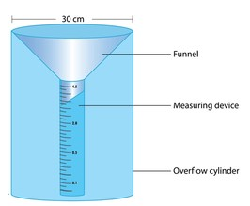
- Weather patterns are observed and recorded daily. Which of the following weather elements is typically measured using a rain gauge shown below?

  - Temperature B. Humidity C. Precipitation D. Sunshine duration

- If it is 3:00 pm at Prime Meridian, what time will it be at a place located at 15° West longitude? A. 2:00 pm B. 4:00 pm C. 3:15 pm D. 2:45 pm
- The earliest human beings adapted to their environment to survive. Which of the following was a primary way early humans obtained food? A. Crop farming B. Herding livestock C. Hunting and gathering D. Trading with other groups

- Archaeological sites provide valuable information about the past. Which of the following is an example of an artefact that might be found at an archaeological site? A. A written diary from the 20th century. B. A photograph of an ancient ruin. C. A stone tool used for cutting. D. A historical documentary film

- Maintaining personal well-being contributes to overall peace. Which of the following is a positive way to cope with stress? A. Avoiding dealing with the problem. B. Talking to a trusted friend or adult. C. Keeping worries to yourself. D. Spending a lot of time alone.

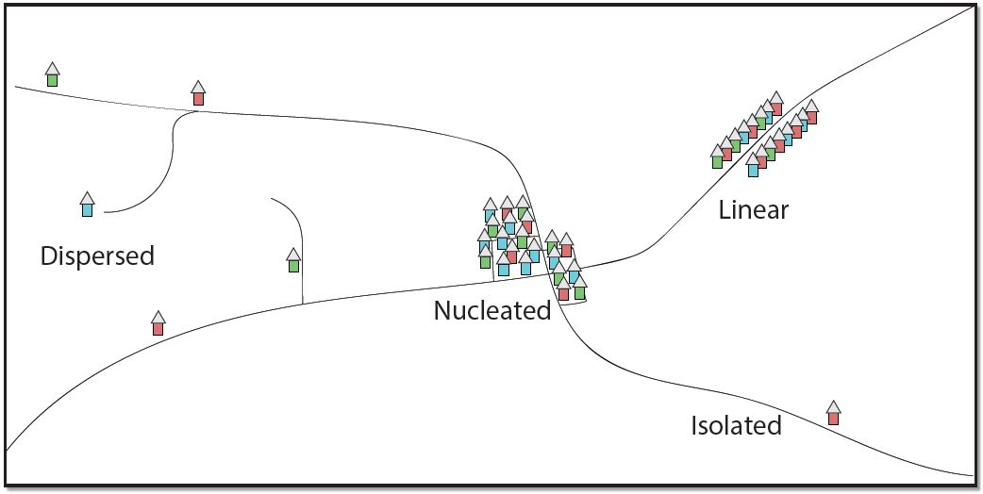
- Grade 7 learners researched different types of settlements. Which type of settlement is characterised by houses spread far apart from each other, often found in rural areas?

D
A

C
B

- Different African communities had various forms of political organisation before colonial rule. From the table shown, select the community that is correctly matched with its traditional leadership structure.
Community Leadership Structure
A Maasai - Age-set system B. Buganda -Council of elders C Asante -Centralised kingdom D Ogiek -Decentralised system
- Developing positive relationships with peers is important in school. Which of the following behaviours promotes positive relationships? A. Being judgemental towards others. B. Listening to others' opinions. C. Interrupting others when they speak. D. Refusing to compromise in disagreements.
- Grade 8 learners studied the causes of the Trans-Atlantic Slave Trade. Which of the following was a primary factor driving the demand for slaves in the Americas? A. Need for skilled craftspeople. B. Labour demand on plantations. C. Desire for religious conversion. D. Demand for soldiers.
- The ancient civilization of Egypt was known for its advanced construction skills. Where was the centre of the pharaoh in the Kingdom? A. Valley of Kings B. Meroe C. Napata D. Fort Jesus
- Early trade routes connected different parts of Africa. Which of the following was a significant trade good exchanged along the Trans-Saharan trade routes? A. Silk B. Porcelain C. Gold D. Cotton textiles
- Values guide our behaviour and choices. Which of the following values is essential for building trust and reliability? A. Dishonesty B. Integrity C. Selfishness D. Arrogance
- Disputes are a normal part of human interaction, but can lead to conflict if not managed. Which of the following is a peaceful method of resolving a dispute between two friends? A. Resorting to physical violence. B. Shouting and arguing loudly. C. Seeking mediation from a neutral person. D. Ignoring the issue completely.
- A learner saw the following symbol used to represent relief on topographical maps. What is its name?
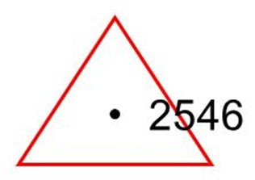
A. A trigonometric station B. A contour line C. A spot height D. A layer tinting
- Grade 8 learners conducted a field study of soil erosion in the school compound. Which of the following tools would be most useful for measuring the depth of erosion channels? A. A compass B. A tape measure C. A thermometer D. A rain gauge
- Citizenship can be acquired in different ways. A person who becomes a citizen of a country after fulfilling specific requirements, such as residing there for a certain period, acquires citizenship by: A. Birth B. Descent C. Registration D. Adoption

- The interactions between African communities before 1900 involved both cooperation and conflict. Which of the following was a common cause of conflict between communities? A. Competition for resources like land and water. B. Exchange of cultural practices. C. Inter-community marriages. D. Participation in joint festivals.

- Population census data is collected to understand the characteristics of a population. Which of the following is a factor that influences population distribution? A. High birth rates B. Availability of fertile land C. Improved medical care D. Migration

SECTION B (80 marks)
Answer ALL questions in this section.
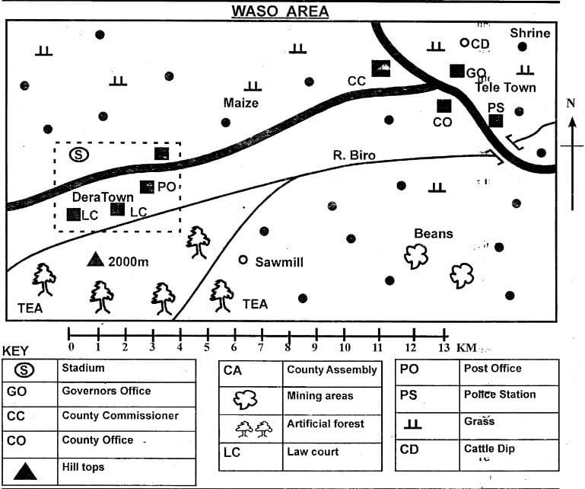
- A Social Studies teacher used the sketch map provided to facilitate a lesson on map reading and interpretation.

a) The teacher asked the learners to give the direction one would take when walking from the Governor’s office to the hill in a straight line. (1 mark)
The direction is
_________________________________________________________________
b) During the lesson, the teacher asked the learners to measure the total distance along the tarmac road in kilometres. (Show your working) (2 marks)

c) The learners studied some economic activities carried out in the area depicted by the map. Name four of these activities as shown by the map symbols or features. (4 marks)
_____________________________________________________________________________

_____________________________________________________________________________

_____________________________________________________________________________
_____________________________________________________________________________
d) The learners were asked to discuss the types of relief features found in the area. Identify three types of relief features that they discussed based on the map, assuming contour lines are present or implied. (3 marks)
____________________________________________________________________________

____________________________________________________________________________
_____________________________________________________________________________
- Human rights are categorised into different groups. Identify five civil and political rights that citizens should enjoy. (5 marks)
__________________________________________________________________________

__________________________________________________________________________

__________________________________________________________________________

__________________________________________________________________________
__________________________________________________________________________
- People move from one place to another for various reasons, leading to different types of migration.
a) Identify three types of migration. (3 marks)
_____________________________________________________________________________

_____________________________________________________________________________
_____________________________________________________________________________
b) Outline three pull factors that attract people to urban areas. (3 marks)
_____________________________________________________________________________

_____________________________________________________________________________
_____________________________________________________________________________
_____________________________________________________________________________
- Grade 7 learners watched a documentary on the ways of life of early human beings during the Stone Age period.
a) Identify two types of tools that they observed being used by early human beings. (2 marks)
_____________________________________________________________________________
_____________________________________________________________________________
b) Give three ways in which the discovery of fire improved the lives of early human beings. (3 marks)
_____________________________________________________________________________
_____________________________________________________________________________
_____________________________________________________________________________
- The members of the Guidance and Counselling Club in the school discussed methods used in resolving conflicts among learners peacefully. Outline two of the methods they are likely to have discussed. (2 marks)
____________________________________________________________________________
_____________________________________________________________________________
- Traditional African societies had various social practices. State three social organizations of the Zulu people. (3 marks)
____________________________________________________________________________

____________________________________________________________________________
_____________________________________________________________________________
- During a discussion, learners explored skills that are important for success in Social Studies and other subjects. Outline five study skills that can help learners perform better. (5 marks)
____________________________________________________________________________
____________________________________________________________________________

____________________________________________________________________________

____________________________________________________________________________
____________________________________________________________________________
- Learners interacted with a story about family nties. Highlight five positive values that are important for maintaining good family ties. (5 marks)
____________________________________________________________________________

____________________________________________________________________________

____________________________________________________________________________

____________________________________________________________________________
_____________________________________________________________________________
- Grade 8 learners visited a historical site to study sources of historical information.
a) Identify four types of non-written sources of historical information that they studied. (4 marks)
_____________________________________________________________________________
_____________________________________________________________________________
_____________________________________________________________________________
_____________________________________________________________________________
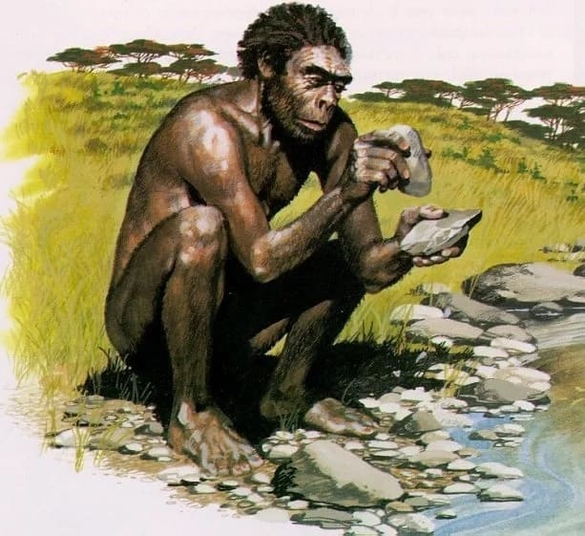
b) During a history lesson, learners were taught about a certain stage of man that began making tools from rocks and stones as shown below.

  - Identify the stage of man shown above: ( 1 mark)

________________________________________________________-
  - State two characteristics of the stage above. (2 marks)
______________________________________________________________________.
______________________________________________________________________.
_____________________________________________________________________.

c) Which scientist is regarded as the father of evolution? (1 mark)
____________________________________________________________________.

d) Identify the following tools used by the early man. (3 marks)
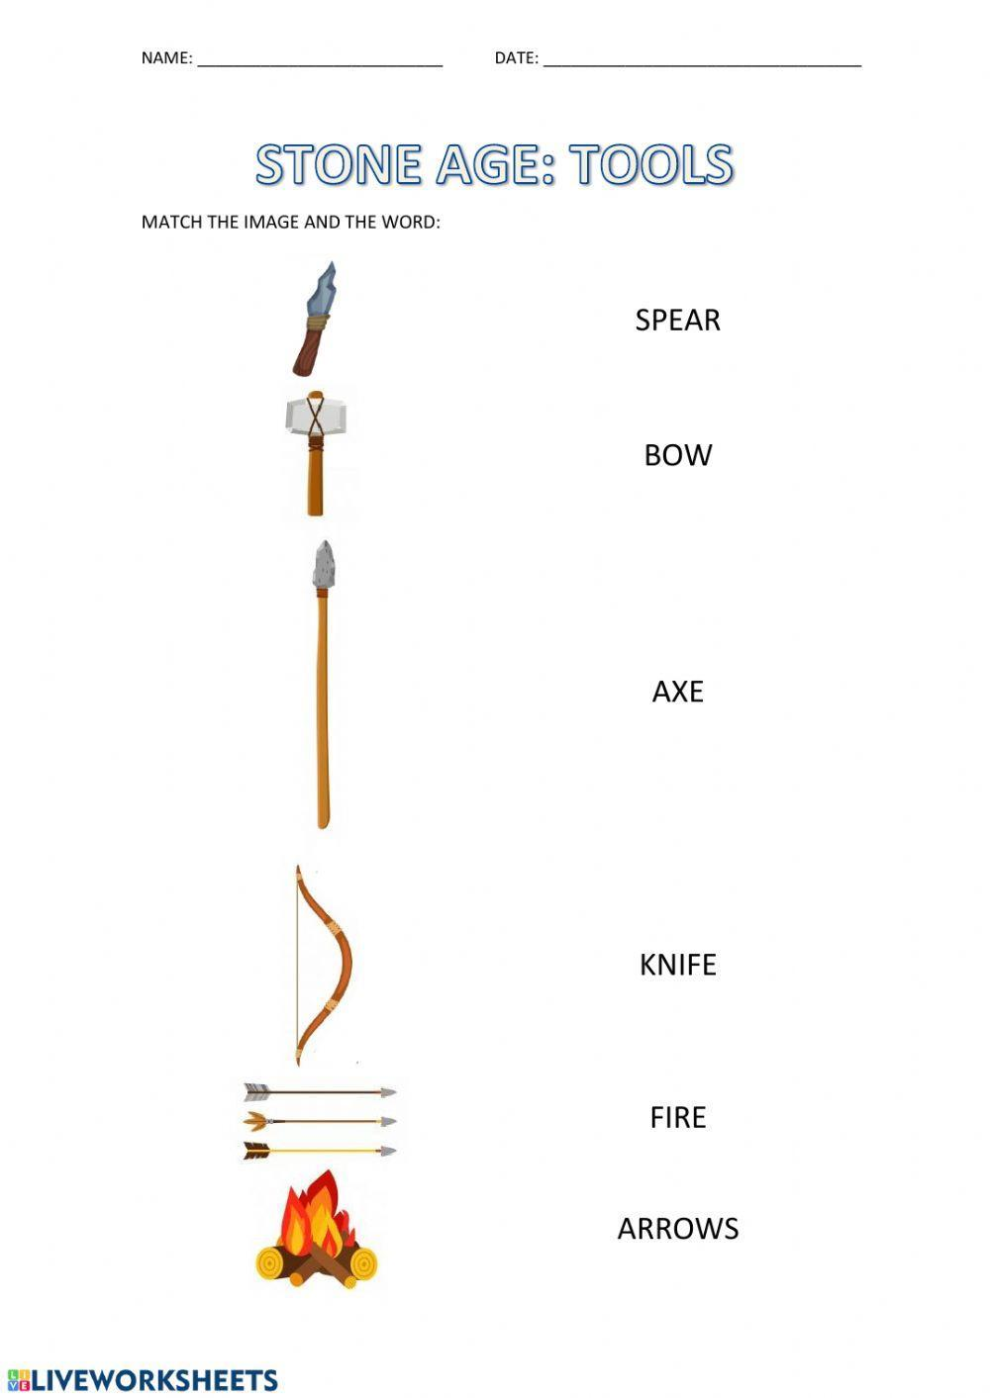

___________________________________.

___________________________________.

___________________________________.

- Members of the Social Studies club discussed the factors leading to population growth in African countries. Outline four factors that contribute to high birth rates in some African societies. (4 marks)
_____________________________________________________________________________

_____________________________________________________________________________

_____________________________________________________________________________
_____________________________________________________________________________
- Dismas wanted to know the regions of the eart. From the following diagram.
- State two theores about the origin of the earth. ( 2 marks)
_____________________________________________________________________________
_____________________________________________________________________________
b) Mention the layer labelled E and F ( 2 marks)

E F
E: ______________________________.
F: ______________________________.
- Grade 8 learners discussed factors influencing climate in Africa.
(a) Mention two characteristics of a Stevensons screen. (2 marks)
_____________________________________________________________________________

_____________________________________________________________________________
_____________________________________________________________________________
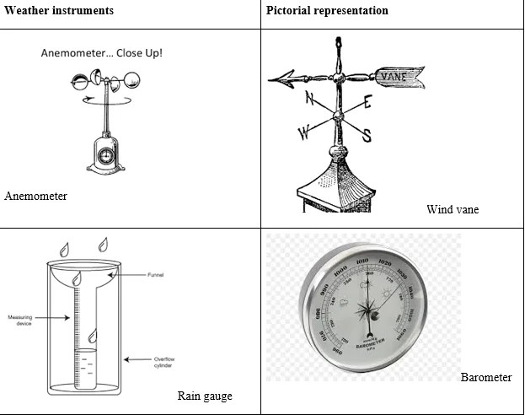
(b) Give the names of the following weather instruments. (2 marks)
________________________ _________________________
(c) Explain how each of the following factors discussed influence the climate of a region:
(i) Altitude (2 marks)
_____________________________________________________________________________

_____________________________________________________________________________
(ii) Distance from the sea (2 marks)
_____________________________________________________________________________

_____________________________________________________________________________
(iii) Ocean currents (2 marks)
_____________________________________________________________________________

_____________________________________________________________________________
- Democracy is a system of government that allows citizens to participate in decision-making. State three ways in which learners can participate democratically in school activities. (3 marks)
___________________________________________________________________________.
___________________________________________________________________________.
___________________________________________________________________________
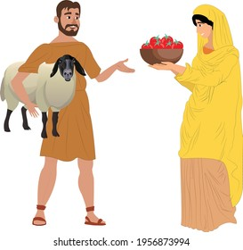
- A Grade 8 teacher used a simple diagram to facilitate learning on a method of traditional trade in Africa. Use it to answer questions a and b.

- (i) Identify the method of trade illustrated in the diagram. (1 mark) __________________________________________________________________
_____________________________________________________________________.
ii) Name one commodity that was commonly exchanged using this method in traditional African societies. (1 mark) ____________________________________________________________________________
b) Explain two challenges faced when using this method of trade. (2 marks)
____________________________________________________________________________
____________________________________________________________________________

c) State three uses of money. (3 marks)

____________________________________________________________________________

____________________________________________________________________________

____________________________________________________________________________

THIS IS THE LAST PRINTED PAGE

Marking scheme
- Social Studies helps learners understand their place in the world. Which of the following aspects is a key focus of geographical studies within Social Studies?
  - B. The relationship between people and their environment. (Geography explores how humans interact with the natural world.)
- Respecting diversity is important for peaceful coexistence in society. Which of the following is an example of respecting diversity?
  - B. Celebrating the cultural practices of different communities. (Respecting diversity means valuing and appreciating different cultures.)
- Weather patterns are observed and recorded daily. Which of the following weather elements is typically measured using a rain gauge shown below?
  - C. Precipitation (A rain gauge is specifically designed to measure the amount of rainfall or other forms of precipitation.)
- If it is 3:00 pm at Prime Meridian, what time will it be at a place located at 15° West longitude?
  - A. 2:00 pm (Every 15° of longitude corresponds to a one-hour difference in time. Since it's West, you subtract one hour.)
- The earliest human beings adapted to their environment to survive. Which of the following was a primary way early humans obtained food?
  - C. Hunting and gathering (Before the development of agriculture and animal domestication, hunting and gathering were the main ways early humans obtained food.)
- Archaeological sites provide valuable information about the past. Which of the following is an example of an artefact that might be found at an archaeological site?
  - C. A stone tool used for cutting. (Artefacts are human-made objects from the past.)
- Maintaining personal well-being contributes to overall peace. Which of the following is a positive way to cope with stress?
  - B. Talking to a trusted friend or adult. (Sharing your worries with someone you trust can provide support and help you find solutions.)
- Grade 7 learners researched different types of settlements. Which type of settlement is characterised by houses spread far apart from each other, often found in rural areas?
  - A. Dispersed settlement (Dispersed settlements have houses scattered over a wide area.)
- Different African communities had various forms of political organisation before colonial rule. From the table shown, select the community that is correctly matched with its traditional leadership structure.
  - A. Maasai - Age-set system (The Maasai had a political system based on age grades.)
- Developing positive relationships with peers is important in school. Which of the following behaviours promotes positive relationships?
  - B. Listening to others' opinions. (Active listening shows respect and encourages understanding in relationships.)
- Grade 8 learners studied the causes of the Trans-Atlantic Slave Trade. Which of the following was a primary factor driving the demand for slaves in the Americas?
  - B. Labour demand on plantations. (The large-scale plantations in the Americas required a massive workforce, leading to the demand for enslaved Africans.)
- A. Valley Of Kings
- Early trade routes connected different parts of Africa. Which of the following was a significant trade good exchanged along the Trans-Saharan trade routes?
  - C. Gold (Gold was a highly valued commodity traded across the Sahara.)
- Values guide our behaviour and choices. Which of the following values is essential for building trust and reliability?
  - B. Integrity (Integrity means being honest and having strong moral principles, which are crucial for trust.)
- Disputes are a normal part of human interaction, but can lead to conflict if not managed. Which of the following is a peaceful method of resolving a dispute between two friends?
  - C. Seeking mediation from a neutral person. (Mediation involves a third party helping to facilitate a peaceful resolution.)
- A learner saw the following symbol used to represent relief on topographical maps. What is its name?
  - C. A spot height (The symbol with '2546' next to it indicates a specific point with a known elevation.)
- Grade 8 learners conducted a field study of soil erosion in the school compound. Which of the following tools would be most useful for measuring the depth of erosion channels?
  - B. A tape measure (A tape measure can be used to directly measure the depth of the channels.)
- Citizenship can be acquired in different ways. A person who becomes a citizen of a country after fulfilling specific requirements, such as residing there for a certain period, acquires citizenship by:
  - C. Registration (This process is also often referred to as naturalization.)
- The interactions between African communities before 1900 involved both cooperation and conflict. Which of the following was a common cause of conflict between communities?
  - A. Competition for resources like land and water. (Competition over essential resources often led to disputes.)
- Population census data is collected to understand the characteristics of a population. Which of the following is a factor that influences population distribution?
  - B. Availability of fertile land (People tend to concentrate in areas with good agricultural potential.)
Section B (80 marks)
Answer ALL questions in this section in the spaces provided.
- A Social Studies teacher used the sketch map provided to facilitate a lesson on map reading and interpretation.
a) The teacher asked the learners to give the direction one would take when walking from the Governor’s office to the hill in a straight line. (1 mark) The direction is South West. (Looking at the map, the hill is located towards the upper right of the Governor's office.)
b) During the lesson, the teacher asked the learners to measure the total distance along the tarmac road in kilometres. (Show your working) (2 marks)
Add the lengths of the two tarmac roads.
(Measurement on the map) x (Scale of the map) = Actual distance
  - Measure the length of the tarmac road on the map using a ruler. Let's say it measures 25 cm.
  - The scale of the map is 1 cm represents 1 km.
  - Therefore, the total distance along the tarmac road is 25 cm x 1 km/cm = 25 km.
c) The learners studied some economic activities carried out in the area depicted by the map. Name four of these activities as shown by the map symbols or features. (4 marks)
  - Farming/Agriculture (indicated by the cultivated land)
  - Trading/Market activities (indicated by the market symbol)
  - Saw milling (indicated by the SM symbol)
  - Mining (indicated by the quarry symbol)
d) The learners were asked to discuss the types of relief features found in the area. Identify three types of relief features that they discussed based on the map. (3 marks)
  - Hill (indicated by the summit and likely concentric contour lines if present)
  - Gentle slope (implied by the spacing of potential contour lines being far apart)
  - Relatively flat area/Plain (implied by the wider spacing or absence of many contour lines in certain areas)
- Human rights are categorised into different groups. Identify five civil and political rights that citizens should enjoy. (5 marks)
  - The right to life
  - The right to freedom of speech and expression
  - The right to vote and participate in political processes
  - The right to a fair trial
  - The right to freedom of assembly and association
- People move from one place to another for various reasons, leading to different types of migration.
a) Identify three types of migration. (3 marks)
  - Internal migration (movement within the borders of a country)
  - International migration (movement across national borders)
  - Rural-urban migration (movement from rural areas to urban areas)
b) Outline three pull factors that attract people to urban areas. (3 marks)
  - Better employment opportunities
  - Access to better education and healthcare facilities
  - More diverse social and cultural amenities
- Grade 7 learners watched a documentary on the ways of life of early human beings during the Stone Age period.
a) Identify two types of tools that they observed being used by early human beings. (2 marks)
  - Hand axes
  - Stone spears
b) Give three ways in which the discovery of fire improved the lives of early human beings. (3 marks)
  - Provided warmth and protection from predators
  - Enabled cooking of food, making it easier to digest and safer to eat
  - Provided light, extending activity into the night
- The members of the Guidance and Counselling Club in the school discussed methods used in resolving conflicts among learners peacefully. Outline two of the methods they are likely to have discussed. (2 marks)
  - Negotiation: Learners directly discussing their issues to find a mutually acceptable solution.
  - Mediation: Involving a neutral third party (like a teacher or peer mediator) to help learners find a resolution.
- Traditional African societies had various social practices. State three social organizations of the Zulu people. (3 marks)
  - Age grades/Amabutho (regiments)
  - Lineage/Clan system
  - Royal family and chieftaincy
- During a discussion, learners explored skills that are important for success in Social Studies and other subjects. Outline five study skills that can help learners perform better. (5 marks)
  - Effective note-taking
  - Time management and organization
  - Active reading and comprehension
  - Research and information gathering
  - Revision and practice
- Learners interacted with a story about family ties. Highlight five positive values that are important for maintaining good family ties. (5 marks)
  - Love and affection
  - Respect and understanding
  - Honesty and trust
  - Communication and listening
  - Support and care
- Grade 8 learners visited a historical site to study sources of historical information.
a) Identify four types of non-written sources of historical information that they studied. (4 marks)
  - Oral traditions (stories, songs, proverbs)
  - Archaeological artefacts (tools, pottery, buildings)
  - Art and rock paintings
  - Physical features and landscapes
b) During a history lesson, learners were taught about a certain stage of man that began making tools from rocks and stones as shown below.
i) Identify the stage of man shown above: (1 mark) handy man/homo habillis. (The image depicts simple, early stone tools.)
ii) State two characteristics of the stage above. (2 marks)
  - Use of crude, basic stone tools.
  - Lifestyle was primarily nomadic or semi-nomadic, relying on hunting and gathering.
c) Which scientist is regarded as the father of evolution? (1 mark) Charles Darwin.
d) Identify the following tools used by the early man. (3 marks)
  - (First tool): Spear
  - (Second tool): Arrows
  - (Third tool): Fire
- Members of the Social Studies club discussed the factors leading to population growth in African countries. Outline four factors that contribute to high birth rates in some African societies. (4 marks)
  - Cultural practices that value large families.
  - Early marriages and childbearing.
  - Limited access to family planning education and services.
  - High infant mortality rates leading families to have more children in the hope that some will survive.
- Dismas wanted to know the regions of the earth. From the following diagram.
a) State two theories about the origin of the earth. (2 marks)
  - The Nebular Hypothesis: This theory suggests that the solar system formed from a large cloud of gas and dust.
  - The Big Bang Theory: While primarily about the origin of the universe, its implications extend to the formation of galaxies and solar systems. (Note: Some might also mention the Planetesimal Theory.)
b) Mention the layer labelled E and F (2 marks)
  - E: Crust (The outermost solid layer of the Earth)
  - F: Mantle (The layer beneath the crust)
- Grade 8 learners discussed factors influencing climate in Africa.
a) Mention two characteristics of a Stevenson screen. (2 marks)
  - It is painted white to reflect sunlight.
  - It has slatted sides to allow free flow of air.
  - Louvered on sides for air circulation or ventilation
  - Cups on legs to prevent moles attack
  - Slant top to flow rain water
  - Raised a meter above ground to avoid flooding or getting heat from the reflected ground heat.
  - (Other possible answers: It is raised above the ground; it has a double roof.)
b) Give the names of the following weather instruments. (2 marks)
  - (First instrument): Anemometer (measures wind speed)
  - (Second instrument): Wind vane/Weather vane (indicates wind direction)
c) Explain how each of the following factors discussed influence the climate of a region:
i) Altitude (2 marks) As altitude increases, temperature generally decreases. This is because the air at higher altitudes is thinner and less able to retain heat.
ii) Distance from the sea (2 marks) Areas near the sea experience a more moderate climate with smaller temperature ranges. The sea heats up and cools down more slowly than land, influencing the temperature of nearby landmasses. Coastal areas also tend to have higher humidity and more rainfall.
iii) Ocean currents (2 marks) Warm ocean currents bring warmer temperatures and higher humidity to coastal regions they pass by. Cold ocean currents bring cooler temperatures and can lead to drier conditions.
- Democracy is a system of government that allows citizens to participate in decision-making. State three ways in which learners can participate democratically in school activities. (3 marks)
  - Electing class representatives or members of the learner council.
  - Participating in school meetings and voicing their opinions.
  - Contributing to the development of school rules and policies through suggestion boxes or forums.
- A Grade 8 teacher used a simple diagram to facilitate learning on a method of traditional trade in Africa. Use it to answer questions a and b.
a) (i) Identify the method of trade illustrated in the diagram. (1 mark) Barter trade.
ii) Name one commodity that was commonly exchanged using this method in traditional African societies. (1 mark) Salt, gold, livestock, grains. (Any one of these or other relevant commodities is acceptable.)
b) Explain two challenges faced when using this method of trade. (2 marks)
  - Difficulty in determining the equal value of different goods.
  - The need for a "double coincidence of wants" - both parties must have what the other desires.
c) State three uses of money. (3 marks)
  - Medium of exchange: It is used to buy and sell goods and services.
  - Store of value: It can be saved and used for future purchases.
  - Unit of account: It provides a common measure for the value of goods and services.
  - etc

